Calculating Greenhouse Gas Emissions from Iron and Steel Production

A component tool of the Greenhouse Gas Protocol Initiative

January 2008.

For additional information please contact Stephen Russell (stephen.russell@wri.org)

Contents

1.0 Overview 3
1.1 Purpose of tool 3
1.2 Domain of application 4
2.0 Organizational and Operational Boundaries 6
2.1 Organizational boundaries 6
2.2 Operational boundaries 7
3.0 Methodologies 8
3.1 Introduction 8
3.2 Stationary Combustion 9
3.2.1 Emissions from electricity generation and 10
reheating furnaces
3.2.2 Emissions from Coke Making 15
3.2.3 Emissions from flaring 19
3.3 Industrial Process Emissions 20
3.3.1 CO₂ methods for process sources 20
3.3.2 CH₄ methods for process sources 22
3.4 Limestone and Dolomite Production 23
3.4.1 Scope 1 emissions 23
3.4.2 Scope 2 emissions 25

Appendices
Appendix I Defaults for estimating the CO₂ emissions from 27
the stationary combustion of fuels
Appendix II Defaults for estimating the CH₄ and N₂O emissions 33
from the stationary combustion of fuels
Appendix III Unit conversion ratios 36

1.0 Overview

1.1 Purpose of tool
This document provides guidance on the estimation of greenhouse gas (GHG) emissions from sources associated with Iron and Steel production. A companion spreadsheet, available at www.ghgprotocol.com, implements the methods described in this document. Together these documents comprise the ‘Iron and Steel Tool’, one of many calculation tools available under the Greenhouse Gas Protocol Initiative, a joint program of the World Resources Institute and the World Business Council for Sustainable Development. The Iron and Steel Tool may be used by companies for internal or public reporting needs, or to participate in a GHG program. Likewise GHG programs, including voluntary or mandatory programs and emission trading schemes, may also customize this tool for their program’s needs.

This guidance explains best practices for the selection and implementation of emission calculation methods, as well as for the collection, documentation, and quality control of data. It often presents different methods for calculating emissions from single sources so that different users of the Iron and Steel tool may match the rigor and detail of their emission inventory to their needs or goals. The guidance has been structured so that any company, regardless of its experience or resources, should be able to produce reliable estimates of its emissions. In particular, default values for virtually all of the parameters in the methods are supplied so that, at the very least, a company needs only to supply data on production volumes or the amount of fuel consumed, for example.

This tool updates the Corporate Standard’s previous guidance for the Iron and Steel sector that was issued in 2002. Major revisions in this update include the provision of methods for specific industrial activities within the overall iron and steel manufacturing process. For example, facilities may now account for the emissions from Direct Reduced Iron and sinter production, as well as coke manufacture. Furthermore, this update includes expanded coverage of stationary combustion sources, such as reheating furnaces, which may contribute significantly to an Iron and Steel facility’s overall emissions.

Users of the Iron and Steel Tool and of other tools available under the GHG Protocol Initiative should consult the Corporate Standard (available at www.ghgprotocol.org), which outlines best practices for general GHG accounting issues. In particular, the Corporate Standard explains why Iron and Steel companies need to have clearly set their organizational and operational boundaries prior to developing an inventory. Because boundaries constitute a critical issue in GHG accounting that has to be considered prior to the use of this tool, Section 2.0 of this guidance summarizes some basic concepts related to the drawing of boundaries (see Section 2.0). Users should consult the Corporate Standard for further guidance and information.

1.2 Domain of application
The manufacture of iron and steel is an energy intensive activity that generates carbon dioxide (CO₂), methane (CH₄), and nitrous oxide (N₂O) emissions at various stages during the production process (Figure 1). Although CO₂ is easily the main GHG emitted, N₂O and CH₄ emissions are not necessarily trivial. Hence, the Iron and Steel tool has incorporated methods for each of these three GHGs whenever possible. Figure 1 summarizes the industrial activities and associated GHG emissions that are considered in this tool.

Please note that this tool does not provide guidance on calculating emissions from transport vehicles (‘mobile combustion’) or the consumption of purchased electricity, heat and steam. Instead, users interesting in calculating emissions from these sources should consult the relevant tools from the Protocol Initiative’s website (www.ghgprotocol.org).

Figure 1. The main GHG emission sources associated with iron and steel production that are considered in this tool. Other sources that are not represented here and that may contribute significantly to a facility’s overall emissions include the on-site transportation of materials and the consumption of purchased electricity, heat and steam. Figure modified from the 2006 IPPC Guidelines for National Greenhouse Gas Inventories.

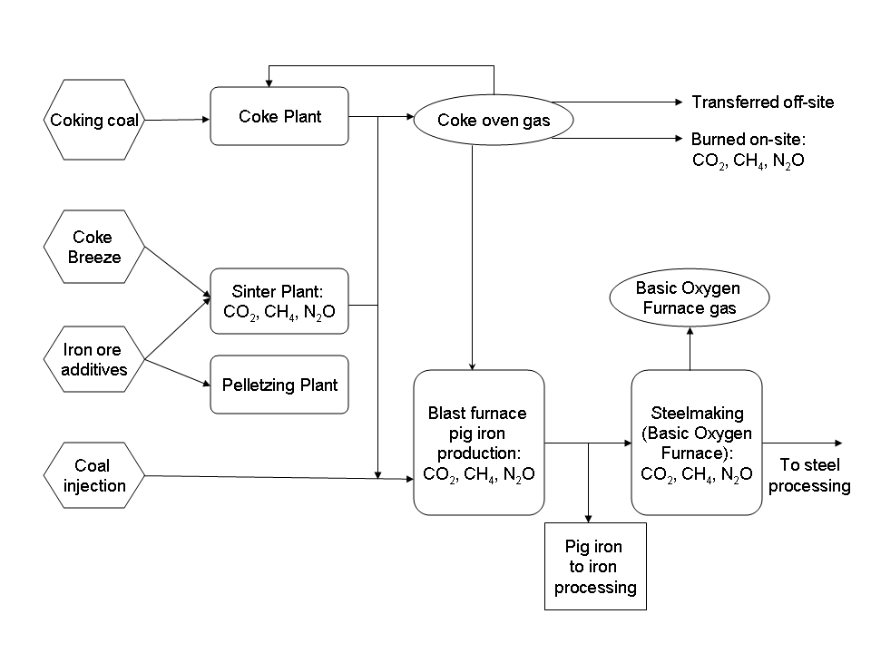

2.0 Organizational and Operational Boundaries
The manner in which organizational and operational boundaries are drawn determines both the sources that are included within an inventory and the emissions from those sources that are reported by a company. Because it is critical that boundaries are consistently and reliably drawn across a company’s constituent facilities and units, organizational and operational boundaries are briefly discussed here. Users are strongly encouraged to consult the Corporate Standard for further guidance.

2.1 Organizational boundaries
For corporate inventories, the exact accounting of the emissions from a source depends on whether that source is wholly owned, a joint venture, subsidiary, or other legal entity. The Corporate Standard provides two approaches for determining how such accounting should be undertaken.

I. Equity share approach
A company reports the percentage GHG emissions from a source that mirrors the percentage financial ownership that company has in the source. One exception relates to fixed asset investments: whenever a company owns only a small part of the shares of a source and does not exert significant financial control, the company does not account for that source’s emissions.

II. Control Approach
A company reports 100% of the emissions from sources over which it has control. Two alternative criteria can be used to define control:
(a) Financial control. A company exerts financial control over the source if it has the ability to direct both the financial and operating policies of the source with a view to gaining economic benefits from such activities.
(b) Operational control. A company has operational control over a source if it has the full authority to introduce and implement its operating policies and practices at the source.

The Corporate Standard encourages companies to use both the equity share approach and a control approach when reporting under voluntary schemes. However, contractual arrangements might determine the ownership of and reporting requirements for GHG emissions, and various other factors might influence the choice of an approach, including:
- Liability and risk management. In assessing risk the equity share and financial control approaches might be most appropriate choices.
- Management information and performance tracking. The control approaches would allow managers to be held accountable for activities under their control.
- Completeness of reporting. Companies may find it difficult to provide matching records or lists of financial assets as proof that sources are correctly accounted for under the operational control approach.
Once an appropriate approach has been determined it should be consistently applied across all of the facilities and units under the control of the reporting company.

2.2 Operational boundaries
Having established its organizational boundaries, a company is then able to establish the scope (or ‘operational boundaries’) of an emissions source. Robustly defined operational boundaries will help a company better manage the full spectrum of GHG risks and opportunities that exist along its value chain. In particular, the use of scopes helps companies meet the reporting requirements of corporate reporting programs, voluntary GHG registries, and other GHG programs.

Emissions fall under one of three scopes. Scope 1 emissions are ‘direct’; that is, they stem from sources that are owned or controlled by the reporting company. Scopes 2 and 3 refer to ‘indirect’ emissions that originate from sources that are controlled by third parties, but that are nonetheless related to the activities of the reporting company. Scope 2 emissions stem from the consumption of purchased electricity, and Scope 3 emissions from all other indirect sources, notably the third party transport of raw materials.

Scope 2 emissions are not considered in this document, although Scope 3 emissions from the production of coke and of limestone and dolomite are. Otherwise, the methods in this tool pertain to Scope 1 emissions.

3.0 Methodologies

3.1 Introduction
Tiers
Many of the methods described in this document are categorized as belonging to one of three tiers. Typically the equations underlying a method do not change amongst tiers. Instead, the values of the parameters forming those equations do, and tiers differ in how much those values are representative of the activities of the reporting company. As the tier level increases from Tier 1 to Tier 3 the values become more specific to the reporting company, leading to greater accuracy in the emissions calculations. A tier system is used here to emphasize the advantages of collecting and using facility-specific information, and to distinguish between the different sets of default factors that are available for some methods (e.g., both Tier 1 and Tier 3 default emission factors are offered for reheating furnaces).

● Tier 1: Tier 1 methods estimate emissions by multiplying production data, such as the volume of fuel used or steel produced, by an industry-specific default emission factor. Tier 1 defaults are supplied for all of the methods in the Iron and Steel Tool, where appropriate.
● Tier 2: Tier 2 methods require data that are less general. For instance, a Tier 2 emission factor might reflect the typical industrial practices within a specific country, whereas a Tier 1 factor constitutes a global default value. Facility-specific data are not considered Tier 2. Tier 2 data might be available from national statistical agencies or industry associations.
● Tier 3: Tier 3 methods require facility-specific data, such as the composition of the fuel combusted at a facility, or the specific types of technologies employed at a facility.

Facilities should ensure that only a single method is used to calculate the emissions from a single source so as to help avoid the double counting of emissions. Particular care should be exercised when fuels have dual energy and process uses, as might happen with blast furnace gases, sinter off gases and coke oven gasses, which, although the product of industrial processes, can also be used to supply energy to industrial processes. Companies are recommended to use the most accurate method possible given the data they have at hand.

Differences between CO₂ and CH₄/N₂O
The recommended methods for calculating CO₂ emissions often differ from those for N₂O and CH₄ emissions. This is because CO₂ emissions are largely determined by the carbon contents of the consumed materials, whereas N₂O and CH₄ emissions are much more influenced by the combustion or emission control technologies employed by the industrial apparatus. Consequently, CO₂ emissions are best determined using a material balance approach that tracks the flow of carbon through the industrial process, whereas N₂O and CH₄ emissions are best determined using equipment or process-specific emission factors. The methods in this guidance will treat CO₂ separately from N₂O and CH₄.

N₂O is only considered by this tool in relation to stationary combustion sources. This is because the N₂O emissions from the industrial processes specific to the Iron and Steel sector are assumed to be negligible.

Global Warming Potentials
The Global Warming Potential (GWP) of a greenhouse gas is a measure of how much a given mass of that gas contributes to global warming. GWPs are given on a relative scale that compares the gas in question to carbon dioxide, whose GWP is therefore 1.0. Over a 100 year time horizon the GWP of CH4 is 21, whereas that of N₂O is 310 (IPPC Second Assessment Report).

In this tool the emissions of each greenhouse gas are multiplied by a relevant GWP to determine the potential impacts on global warming of these emissions. The product of this multiplication is given in units of CO₂-equivalents (metric tones CO₂-e.). The spreadsheet program that accompanies this guidance allows facilities to calculate both the absolute emissions of individual GHGs and their CO₂-equivalency.

3.2 Stationary Combustion
Stationary combustion emissions account for roughly half of the overall emissions from an Iron and Steel company and include CO₂, CH₄, and N₂O emissions. Stationary combustion sources belong to four main types:
- Electricity generation; e.g., captive power plant boilers
- Re-heating furnaces (other coal and oil use); e.g., mill sections
- Coke production
- Flaring

3.2.1 Emissions from Electricity Generation and Reheating Furnaces

CO₂
The calculation of CO₂ emissions from Electricity Generation and Reheating Furnaces requires data on the carbon content, heating value and oxidation fraction of the consumed fuel(s). Default, Tier 1 values for each of these factors are supplied.

The following sections provide information on these factors and on how the fuel consumption data should be gathered.

Fuel Consumption Data
Facilities need to collate data on the amount of fuel consumed over the reporting year and disaggregate these data by fuel type. These data can come directly from on-site metering of the fuel inputs into the combustion units or from the output of these units. Alternatively, the data may be calculated from purchase or delivery records, in which case companies should be careful to account for inventory stock changes following Equation 1:

Equation 1 | Accounting for Changes in Fuel Stocks
Total Annual Fuel Consumption = Annual Fuel Purchases - Annual Fuel Sales + Fuel
Stock at Beginning of Year - Fuel Stock at End of Year

Fuel Carbon Content and Heating Values
The carbon content of a fuel is the fraction or mass of carbon atoms relative to the total mass or number of atoms in the fuel; it is thus a measure of the potential CO₂ emissions from that fuel’s combustion.

The carbon content of a given fuel can show variation over space and time (see Figure 2 for an example). The extent of variation can depend on the units chosen to express the carbon content data - less variability is often seen when the data are expressed on an energy basis (e.g., Kg carbon/MJ or tonnes carbon/ million Btu) compared to a mass or volume basis (e., kg C/ Kg fuel). Carbon content values can be converted to energy units using heating or calorific values.
Figure 2. Spatial variation in the carbon content of pipeline-quality natural gas in the U.S.
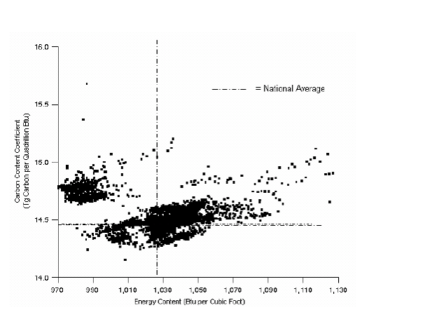
Source: Energy Information Administration (1994), Emissions of Greenhouse Gases in the United States 1987-1992.

A fuel’s heating value is the amount of heat released during the combustion of a specified amount of that fuel (example units are MJ/Kg, thousand Btu/lb, and MMBtu/bbl). Two alternative metrics of heating value may be used to adjust carbon content data: lower heating value (LHV; also known as Net Calorific Value (NGV)) and higher heating value (HHV; also known as Gross Calorific Value (GCV)). These metrics differ in how they consider the different physical states (liquid or gaseous) that water exists in following combustion. The HHV includes the latent energy of condensation of water following combustion, whereas the LHV is obtained by subtracting the heat of vaporization of the water produced by combustion from the higher heating value. More specifically:

Equation 2 | Inter-converting HHV and LHV data
LHV = HHV – 0.212H -0.0245M -0.008Y
Where:
M = % moisture
H = % hydrogen
Y = percent oxygen

A commonly accepted approximation for inter-converting LHV and HHV data is to assume that the LHV is 95% of the HHV for solid fuels, such as coal and oil, but 90% of the HHV for gaseous fuels, such as natural gas.

One benefit of the HHV over the LHV is that the relationship between carbon content and heating values is more direct using the former. This is because the LHV is partly a function of the fuel’s moisture content, which can vary significantly. In North America the convention is to use HHV, whereas LHV is used outside North America.
Carbon content factors can be converted to an energy scale using heating values with Equation 3:

Equation 3 | Converting carbon content factors from a mass or volume basis to an energy basis
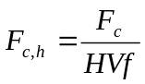
Where:
F_{c,h} = Carbon content of fuel on a heating value basis (e.g., short tons carbon / million Btu or metric tons carbon / GJ)
F_{c} = Carbon content of fuel on a mass or volume basis (e.g., short ton carbon / short ton)
HVf = Heating value of fuel (e.g., MJ/Kg, thousand Btu/lb or MMBtu/bbl, etc.)

To summarize, given the variability that can exist in fuel composition, companies are encouraged to use Tier 3, facility-specific values for carbon content and heating values whenever possible. Ideally, the carbon content factors should be expressed on an energy scale using higher heating values. Tier 3 information may be available from suppliers or from the Material Safety Data Sheets for purchased fuels. In case facility-specific values can not be derived, plants may use the Tier 1 default values in Appendix I. Companies may use a mix of plant-specific and default values in a single calculation (e.g., custom carbon content factor, but default HHV data). Tier 2 values may be available from national statistical agencies and other national-level organizations.

Fuel Fraction Carbon Oxidation Factor
A small fraction of a fuel’s carbon content can escape oxidation and remain as a solid after combustion in the form of ash or soot (for solid fuels) or particulate emissions (for natural gas and other gaseous fuels). This unoxidized fraction is a function of several factors, including fuel type, combustion technology, equipment age, and operating practices. This fraction can be assumed to contribute no further to CO₂ emissions, so it is easily corrected for in estimating CO₂ emissions. The stationary combustion CO₂ methods in this tool use an ‘oxidation factor’ to account for the unoxidised fraction (where 1.00 = complete oxidation). In general, variability in the oxidation factor is low for gaseous and liquid fuels, but can be much larger for solid fuels. For example, an Australian study of coal-fired boilers found that the oxidation factor ranged from 0.99 – 0.88 (IPCC, 2006).

The preferred approach for developing a Tier 3 facility-specific oxidation factor is to measure the quantity of residual solid left over from the combustion process and then analyze that residue’s carbon content. However, if this is not possible a Tier 1 default value of 1.00 can be assumed.

Calculating CO₂ Emissions
Facilities should first ensure that all units are consistent with each other (Appendix III provides unit conversion ratios). Facilities are encouraged to express any Tier 2/3 carbon content data on an energy basis using HHV values, before using Equation 4 to calculate the emissions. Otherwise, when these data are expressed on a mass or volume basis, Equation 5 should be used. Default, Tier 1 values for use with Equations 4 and 5 are given in Appendix I.

Equation 4 | Calculating CO₂ emissions using carbon content data that are expressed on a mass or volume basis
Mass basis: 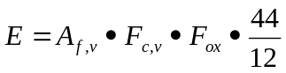

Volume basis: 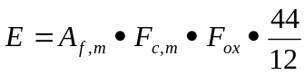
Where:
E = Amount of CO₂ emitted (metric tons)
A_{f,v} = Volume of fuel consumed (e.g., liters, gallons, m3, etc.)
A_{f,m} = Mass of fuel consumed (e.g., kg, short ton, etc.)
F_{c,v} = Carbon content of fuel on a volume basis (e.g., short tons carbon / gallon)
F_{c,m} = Carbon content of fuel on a mass basis (e.g., short tons carbon / short ton)
F_{OX} = Fraction oxidation factor
44/12 = The ratio of the molecular weight of carbon to that of CO₂

Equation 5 | Calculating CO₂ emissions from stationary combustion sources using carbon content data expressed on an energy basis:
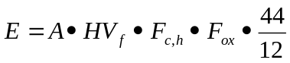

Where:
E = Amount of CO₂ emitted (metric tonnes)
A = Mass of fuel consumed (e.g., metric tonnes)
HV_{f} = Heating value of fuel (e.g., MJ/Kg or thousand Btu/lb)
F_{c,h} = Carbon content of fuel on a heating value basis (e.g., short tons C/million Btu or metric tonnes C/GJ)
F_{OX} = Fraction oxidation factor
44/12 = The ratio of the molecular weight of carbon to that of CO₂

CH₄ and N₂O emissions
The N₂O and CH₄ emissions from Electricity Generation and Reheating Furnaces can be calculated using Equation 6. This tool provides two sets of default emission factors that can be used with Equation 6. Appendix II lists fuel-specific default factors that are Tier 1. Table 1 lists equipment-specific factors that are Tier 3. Facilities are encouraged to use the Tier 3 factors whenever possible, although they may instead use the Tier 1 factors if they do not have reliable data on the equipment in use at their combustion units. Tier 2 factors that are fuel- and country-specific, but not equipment-specific, may also be used and may be obtainable from national statistical agencies and other national-level organizations. Note that the default N₂O factors are generally based on limited measurements and have a high degree of uncertainty.

Equation 6 | Calculating N₂O and CH₄ emissions from stationary combustion sources
Tier 1: E = A_{f} •HHV_{f} •EF * GWP

Tier 3: E = A_{f} •HHV_{f} •ESEF * GWP
Where:
E = Amount of either N₂O or CH₄ emitted (metric tonnes CO₂-equivalent)
A_{f} = Amount of fuel combusted on a mass or volume basis (e.g., lb, bbl, etc.)
EF = Tier 1 fuel-specific emission factor (see Appendix II for default values)
ESEF = Tier 3 Equipment-specific emission factor (see Table 1 for default values)
GWP = 21 for CH₄ or 310 for N₂O

Table 1: Tier 3 equipment-specific CH₄ and N₂O default emission factors for
stationary combustion sources

Technology |  |  | LHV/NCV basis: kg/TJ fuel |  | HHV/GCV basis: kg/TJ fuel
Basic Technology |  | Configuration | CH₄ | N₂O | CH₄ | N₂O
Liquid fuels | Residual fuel oil/ Shale oil boilers |  | 3.000 | 0.300 | 3.158 | 0.316
Liquid fuels | Gas/Diesel oil boilers |  | 0.200 | 0.400 | 0.211 | 0.421
Liquid fuels | Large stationary diesel oil engines >600hp (447kW) |  | 4.000 | N/A | 4.211 | N/A
Liquid fuels | Liquified Petroleum Gases (LPG) boilers |  | 0.900 | 4.000 | 0.947 | 4.211
Solid fuels | Other bituminous /Sub-bituminous overfeed stoker boilers |  | 1.000 | 0.700 | 1.053 | 0.737
Solid fuels | Other bituminous /Sub-bituminous underfeed stoker boilers |  | 14.000 | 0.700 | 14.737 | 0.737
Solid fuels | Other bituminous/sub-bituminous pulverised | Dry bottom, wall fired | 0.700 | 0.500 | 0.737 | 0.526
Solid fuels | Other bituminous/sub-bituminous pulverised | Dry bottom, tangentially fired | 0.700 | 1.400 | 0.737 | 1.474
Solid fuels | Other bituminous/sub-bituminous pulverised | Wet bottom | 0.900 | 1.400 | 0.947 | 1.474
Solid fuels | Other bituminous spreader stokers |  | 1.000 | 0.700 | 1.053 | 0.737
Solid fuels | Other bituminous/sub-bituminous fluidised bed combustor | Circulating bed | 1.000 | 61.000 | 1.053 | 64.211
Solid fuels | Other bituminous/sub-bituminous fluidised bed combustor | Bubbling bed | 1.000 | 61.000 | 1.053 | 64.211
Natural Gas | Boilers |  | 1.000 | 1.000 | 1.111 | 1.111
Natural Gas | Gas-fired gas turbines >3MW |  | 4.000 | 1.000 | 4.444 | 1.111
Natural Gas | Natural gas-fired reciprocating engines | 2-Stroke lean burn | 693.000 | N/A | 770.000 | N/A
Natural Gas | Natural gas-fired reciprocating engines | 4-Stroke lean burn | 597.000 | N/A | 663.333 | N/A
Natural Gas | Natural gas-fired reciprocating engines | 4-Stroke rich burn | 110.000 | N/A | 122.222 | N/A
Biomass | Wood/wood waste boilers |  | 11.000 | 7.000 | 11.579 | 7.368
Source: IPCC 2006, Volume 2, Chapter 2.

3.2.2 Emissions from Coke Making
CO₂
This guidance provides two methods for calculating the CO₂ emissions from coke manufacture. Facilities should chose between the two based on whether or not the coke they consumed was produced onsite. This is because coke manufacture may entail the use of by-products from industrial activities that took place within the site of coke production. Facilities that consume coke produced off-site should not account for the emissions from these by-products; otherwise, emissions from these by-products might be double-counted.

The separate consideration of emissions from onsite and offsite coke manufacture also allows the separation of emissions based on ownership. In other words, if coke is purchased from an entity outside the organizational boundaries of the reporting company, the associated emissions are Scope 3, not Scope 1. Likewise, if the coke production facility is offsite, but located within the corporate boundaries of the reporting company, the facility’s emissions fall under Scope 1. Figure 3 demonstrates this principle.

Figure 3. Diagram illustrating how the accounting of emissions from coke
manufacturing facilities depends on whether those facilities exist within the
organizational boundaries of the reporting company.
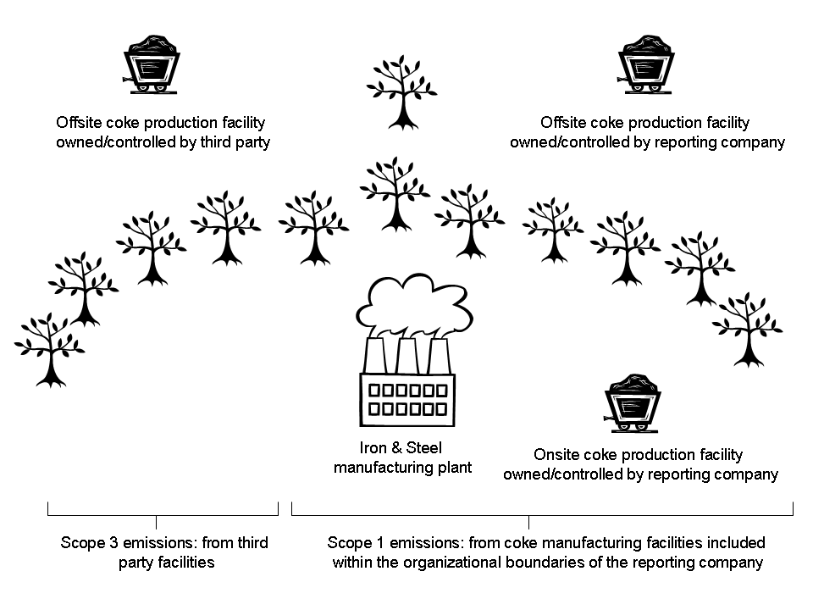

Emissions from onsite and offsite coke production should be estimated using Equations 7 and 8, respectively. Both equations require carbon content data for each material input into the coke plant. Companies are encouraged to use facility-specific (Tier 3) values whenever possible. However, if companies do not have the requisite information they may then use the default, Tier 1 values (see Table 2).
Equation 7 | Calculating CO₂ emissions from onsite coke production
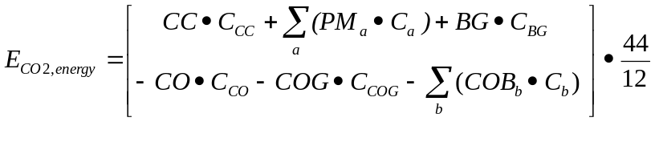

Where:
E_{CO2, energy} = emissions of CO₂ from onsite coke production, tonnes
CC = quantity of coking coal consumed for coke production in onsite integrated iron and steel production facilities, tonnes
PM_{a} = quantity of other process material a, other than those listed as separate terms, such as natural gas and fuel oil, consumed for coke and sinter production in onsite coke production and iron and steel production facilities, tonnes
BG = quantity of blast furnace gas consumed in coke ovens, m₃ (or other unit such as tonnes or GJ.
CO = quantity of coke produced onsite at iron and steel production facilities, tonnes
COG = quantity of coke oven gas transferred offsite, m3 (or other unit such as tonnes or GJ).
COB_{b} = quantity of coke oven by-product b, transferred offsite to other facilities, tonnes
C_{x} = carbon content of material input or output x, tonnes C/(unit for material x) [e.g., tonnes C/tonne]

Equation 8 | Calculating CO₂ emissions from offsite coke production
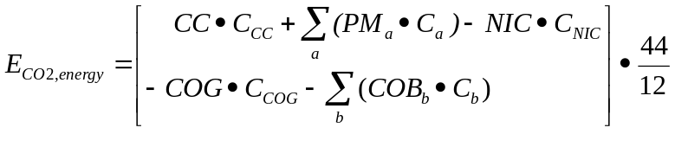

Where:
ECO₂, energy = emissions of CO₂ from offsite coke production (tonnes)
CC = quantity of coking coal used in non-integrated coke production facilities (tonnes)
PM_{a} = quantity of other process material a, other than coking coal, such as natural gas and fuel oil consumed nationally in non-integrated coke production (tonnes)
NIC = quantity of coke produced offsite in non-integrated coke production facilities nationally (tonnes)
COG = quantity of coke oven gas produced in offsite non-integrated coke production facility (tonnes)
COB_{b}= quantity of coke oven by-product b, produced nationally in offsite non-integrated facilities and transferred offsite to other facilities (tonnes)
C_{x} = carbon content of material input or output x, tonnes C/(unit for material x) [e.g., tonnes C/tonne]

Table 2. Carbon contents for materials consumed in process sources
Process Materials | Carbon Content*  (kg C/kg)
Blast Furnace Gas | 0.17
Charcoalª | 0.91
Coal | 0.67¹
Coal tar | 0.62
Coke | 0.83
Coke Oven gas | 0.47
Coking Coal | 0.73
Direct reduced Iron (DRI) | 0.02
Dolomite | 0.13
EAF Carbon Electrodes | 0.82²
EAF Charge Carbon | 0.83³
Fuel Oil | 0.86⁴
Gas Coke | 0.83
Hot Briquetted iron | 0.02
Limestone | 0.12
Natural Gas | 0.73
Oxygen Steel Furnace Gas | 0.35
Petroleum Coke | 0.87
Purchased pig Iron | 0.04
Scrap Iron | 0.04
Steel | 0.01
Sources and Notes:
* Default values are consistent with those provided in the IPCC 2006 Guidelines (Volume 2) and have been calculated with the following assumptions:
¹ Assumed other bituminous coal
² Assumed 80% petroleum coke and 20% coal tar
³ Assumed coke oven gas
⁴ Assumed gas/diesel fuel
ª The CO2 emissions from charcoal can be calculated using this carbon content value, but are reported as zero for the purposes of corporate inventories.

CH₄
The CH4 emissions from coke manufacture can be calculated using Equation 9, regardless of whether the coke was produced onsite of offsite.

Equation 9 | Calculating CH₄ emissions from coke production
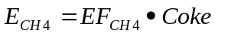

Where:
E_{CH4} = The amount of CH₄ emitted from coke manufacture.
EF_{CH4} = The CH₄ emission factor (g CH₄ / tonne coke)
Coke = The amount of coke produced (metric tonnes coke)

The default value for the CH₄ emission factor is: 0.1 g/metric tonne coke.

3.2.3 Emissions from Flaring

Flares are a special category of stationary combustion sources because they are not typically operated for the purpose of producing useful energy and because they tend to function at relatively low combustion efficiencies (i.e., they allow a larger percentage of the fuel to pass unburnt). Flaring is generally uncommon in Iron and Steel operations as most integrated plants recycle the coke-oven and blast furnace gases they produce. Exceptions arise when industrial operations are interrupted and systems must be taken offline.

The CO₂ and CH₄ emissions from flares should be estimated following Equations 10 and 11, respectively. There is no method to calculate flare N₂O emissions.

CO₂

Equation 10 | Calculating CO₂ emissions from flares
CO₂ Emissions = Q x 5.16⁻⁵x C_{mole ratio}

Where:
CO₂ Emissions = annual emissions from flaring (tonne/yr)
Q = Volume Gas Flared (scf/yr)
C_{mole ratio}= Σ(lbmole HC_{i}/lbmole gas * lbmoles C/lbmole HC_{i}), where HC_{i} = Hydrocarbon molecule i
5.16 * 10⁻⁵ = 1/Molar Volume (lbmole 379.3scf) * Combustion Efficiency (.98) * 1 lbmoles CO2/lbmole C * MW_{CO2} (44 lb/lbmole) * tonne/2204.6 lb)

CH₄

Equation 11 | Calculating CH₄ emissions from flares
CH₄ Emissions = Q_{fg} • 3.83 ^{–7} • CH₄ mole ratio • GWP

Where:
CH₄ Emissions = annual emissions from flaring (tonne/yr)
Q_{fg} = Volume Gas Flared (scf/yr)
CH₄ mole ratio = lbmole CH₄/ lbmoles gas
3.83 * 10⁻⁷ = 1/Molar Volume (lbmole 379.3scf) * .02 (% Uncombusted CH₄/100) * MW_{CH4} (16 lb/lbmole) * tonne/2204.6 lb)
GWP = 21

3.3 Industrial Process Emissions
The four main sources that contribute to process GHG emissions are:
- Sinter making
- Pelletzing
- Iron and steel making
- Direct Reduced Iron (DRI) production
CO₂ and CH₄ are the main GHGs emitted by process sources. N₂O emissions may also occur, but these are considered very small and are not considered further by the Iron and Steel Tool.

3.3.1 CO₂ methods for process sources
These methods require data on the carbon content of the materials consumed during the industrial processes. Companies are encouraged to use Tier 3, facility-specific values whenever possible. However, the default, Tier 1 values in Table 2 may be used in the absence of other, more detailed information.

Sinter production
The CO₂ emissions should be calculated following Equation 12.
Equation 12 | Calculating CO₂ emissions from sinter production
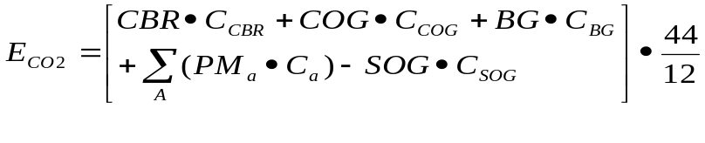

Where:
E_{CO2} = emissions of CO₂ from sinter production (tonnes)
CBR = quantity of purchased and onsite produced coke breeze used for sinter production (tonnes)
COG= quantity of coke oven gas consumed in blast furnace in sinter production (m³)
BG = quantity of blast furnace gas consumed in sinter production (m³)
PM_{a} = quantity of other process material a, other than those listed as separate terms, such as natural gas and fuel oil, consumed during sinter production (tonnes)
SOG = quantity of sinter off gas transferred offsite either to iron and steel production facilities or other facilities (m³)
C_{x} = carbon content of material input or output x, tonnes C/(unit for material x) [e.g., tonnes C/tonne]. See the default values in Table 2.

Iron and Steel Production
The CO₂ emissions from iron and steel making can be calculated following Equation 13.

Equation 13 | Calculating CO₂ emissions from iron and steel production
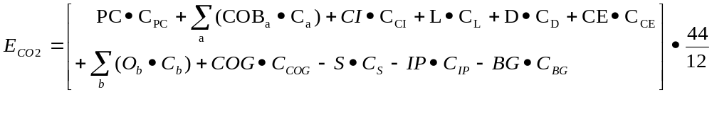

Where:
E_{CO2} = emissions of CO₂ from iron and steel production (tonnes)
PC = quantity of coke consumed in iron and steel production (not including sinter production) (tonnes)
COB_{a} = quantity of onsite coke oven by-product a, consumed in blast furnace (tonnes)
CI= quantity of coal directly injected into blast furnace (tonnes)
L = quantity of limestone consumed in iron and steel production (tonnes)
D = quantity of dolomite consumed in iron and steel production (tonnes)
CE = quantity of carbon electrodes consumed in EAFs (tonnes)
O_{b} = quantity of other carbonaceous and process material b, consumed in iron and steel production, such as sinter or waste plastic (tonnes)
COG= quantity of coke oven gas consumed in blast furnace in iron and steel production (m3)
S = quantity of steel produced (tonnes)
IP = quantity of iron production not converted to steel (tonnes)
BG = quantity of blast furnace gas transferred offsite (m3)
Cx = carbon content of material input or output X, tonnes C/(unit for material X) [e.g., tonnes C/tonne]. See the default values in Table 2.

Direct Reduced Iron (DRI) Production
The CO₂ emissions from DRI production stem from the combustion of fuel, coke breeze, metallurgical coke or other carbonaceous materials. The emissions can be calculated following Equation 14.

Equation 14 | Calculating CO₂ emissions from DRI production
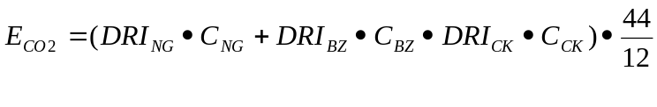
Where:
E_{CO2} = emissions of CO₂ (tonnes)
DRI_{NG} = amount of natural gas used in direct reduced iron production (GJ)
DRI_{BZ} = amount of coke breeze used in direct reduced iron production (GJ)
DRI_{CK} = amount of metallurgical coke used in direct reduced iron production (GJ)
C_{NG} = carbon content of natural gas (tonne C/GJ) (see Table 2)
C_{BZ} = carbon content of coke breeze (tonne C/GJ) (see Table 2)
C_{CK} = carbon content of metallurgical coke (tonne C/GJ) (see Table 2)

3.3.2 CH₄ methods for process sources
The CH₄ emissions from steel-making are assumed to be negligible and are therefore not discussed here. Instead this toll provides methods for estimating the CH4 emissions from sinter, pig iron and DRI production using Equations 15, 16 and 17, respectively.

Tier 1 default values for the emission factors used in Equations 15 and 17 are given in Table 3. These values should only be used in the absence of facility-specific data that would allow the derivation of Tier 3 values. Please note that no default is available for pig iron production (Equation 16).

Equation 15 | Calculating CH₄ emissions from sinter production
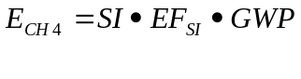

Equation 16 | Calculating CH₄ emissions from pig iron production
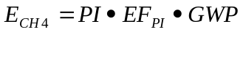

Equation 17 | Calculating CH₄ emissions from DRI production
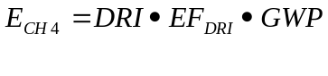

Where:
E_{CH4} = emissions of CH₄ (kg)
SI = quantity of sinter produced (tonnes)
PI = quantity of iron produced, including iron converted to steel and not converted to steel (tonnes)
DRI = quantity of direct reduced iron produced (tonnes)
EF_{X} = emission factor, kg CH4/tonne X produced
GWP = 21

Table 3. Tier 1 CH₄ Emission Factors for process emission sources
Process | Emission Factor
Sinter production | o.o7 kg per tonne of sinter produced
DRI Production | 1 kg/TJ (on a net calorific basis)
Source: IPCC 2006 (Volume 3, Chapter 4)

3.4 Limestone and Dolomite Production
Two different methods are presented here to allow facilities to calculate the CO₂ emissions from limestone and dolomite production. The choice between them is determined by the available data and by whether or not production occurs within the organizational boundaries of the reporting company. If the associated emissions are direct (Scope 1) then the Scope 1 method should be used. If the associated emissions are indirect (Scope 3) and the reporting company does not have access to the data required by the Scope 1 method, it should use the Scope 3 method instead.

3.4.1 Scope 1 emissions
The Scope 1 method requires data on the type(s) and quantity(ies) of the carbonate(s) consumed to produce lime, as well as the respective emission factor(s) for these carbonate(s). Emissions should be calculated following Equation 18. Note that this method assumes that no lime kiln dust (LKD) is recycled to the kiln, because such recycling is rarely carried out.
Equation 18 | Calculating Scope 1 CO₂ emissions from lime production
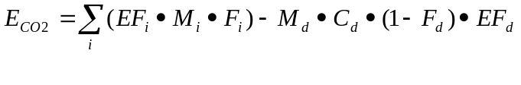

Where:
E_{CO2} = emissions of CO₂ from lime production (tonnes)
EF_{i} = emission factor for carbonate I (tonnes CO₂/tonne carbonate). See defaults in Table 4.
M_{i} = weight or mass of carbonate i consumed (tonnes)
F_{i} = fraction calcination achieved for carbonate I (fraction). See below
M_{d} = weight or mass of LKD (tonnes)
C_{d} = weight fraction of original carbonate in the LKD (fraction). See below
F_{d} = fraction calcination achieved for the LKD (fraction). See below
EF_{d} = emission factor for the uncalcined carbonate in the LKD (tonnes CO₂/tonne carbonate). See below

Companies are encouraged to use facility-specific values for the parameters in Equation 18 whenever possible. However, default Tier 1 values may be used in the absence of other, more detailed data. Specifically:
• Carbonate emission factor (EF_{i}). Refer to the values in Table 4.
• Carbonate calcination fraction (F_{i}). A value of 1.0 (ie. 100 % calcination) may be
assumed.
• LKD calcination fraction (F_{d}). A value of 1.0 (ie. 100 % calcination) may be assumed.
• Weight fraction of original carbonate in the LKD (C_{d} ). Because calcium carbonate is
overwhelmingly the dominant carbonate present in the raw materials used in limestone and dolomite production, facilities may assume that it makes up 100 percent of the carbonate remaining in the LKD. Hence, the Tier 1 default for C_{d} is equal to the calcium carbonate ratio in the raw material feed to the kiln.

Table 4. Tier 1 emission factors for common carbonate species
Carbonate | Mineral name(s) | Emission factor (tonnes CO2/tonne carbonate)
CaCO₃ | Calcite or aragonite | 0.44
MgCO₃ | Magnesite | 0.52
CaMg(CO₃)₂ | Dolomite | 0.48
FeCO₃ | Siderite | 0.38
Ca(Fe,Mg,Mn)(CO₃)₂ | Ankerite | 0.41-0.48
MnCO₃ | Rhodochrosaite | 0.38
Na₂CO₃ | Sodium carbonate or soda ash | 0.41
Source: IPCC 2006 Guidelines, Volume 2, Table 2.1.

3.4.2 Scope 3 emissions
The reporting company should calculate the Scope 3 (i.e. indirect) CO₂ emissions from lime production using Equation 19. This is an output-based method that requires data only on the amount of lime that facilities import. These data are then multiplied by an emission factor that is based on the stoichiometric ratios and CaO / CaO·MgO contents of a combination of lime types that is assumed to typify the output of the lime production industry. The resulting estimate of CO₂ emissions is then corrected for the production of hydrated lime and of any Lime Kiln Dust (LKD) that is not returned to the kiln.

Equation 19 | Calculating Scope 3 CO₂ emissions from lime production

Where:
E_{CO2} = emissions of CO₂ from lime production (tonnes)
EF_{lime} = emission factor for the specific type of lime that is imported. The default value is: 0.75 tonnes CO₂/ tonne lime produced. See below
M_{L} = weight or mass of lime produced (tonnes)
H_{fraction} = Fraction of imported lime that is hydrated. Default value: 0.1
H_{water} = Water content of hydrated lime (fraction). Default value: 0.1
LKD_{CF} = Correction factor for the production of lime kiln dust (LKD) that is not returned to the lime kiln. Default value: 1.02

The default emission factor assumes that the produced lime is 85% high calcium lime and 15% dolomitic lime (see Equation 20). Should the reporting company have access to more accurate information, it should adjust the default emission factor based on Equation 20 and Table 5 to reflect the actual combination of lime types present in the imported lime and on the CaO / CaO·MgO contents of these types.

Equation 20 | Deriving a custom CO₂ emission factor for Scope 3 emissions

Where:
EF_{lime} = aggregated emission factor for lime produced
Proportion_{i} = Fraction of lime type i in the lime imported by the reporting company
EF_{i} = Emission factor for lime type i (tonnes CO₂/ tonne lime produced) (see Table 5)

Table 5: Properties of various lime types
Lime Type | Stoichiometric Ratio  (tonnes CO₂ per tonne CaO or CaO∙MgO)  (1) | Range of CaO Content (%) | Range of MgO content (%) | Default value for CaO or CaO∙MgO content (fraction)  (2) | Default emission factor (tonnes CO2 per tonne lime)  (1)●(2)
High-calcium lime | 0.785 | 93-98 | 0.3-2.5 | 0.95 | 0.75
Dolomitic lime | 0.913 | 55-57 | 38-41 | 0.95 or 0.85 | 0.86 or 0.77
Hydraulic lime | 0.785 | 65-92 | NA | 0.75 | 0.59
Source: IPCC 2006 Guidelines, Volume 2, Table 2.1.

Appendix I: Defaults for estimating the CO₂ emissions from the stationary combustion of fuels

Both Tables I-1 and I-2 below contain Tier 1 defaults for various fuel properties (fuel heating value, carbon content and carbon oxidation fraction) that should enable companies to calculate the CO₂ emissions from fuel combustion.

Table I-1. Tier 1 defaults for carbon content values

Fuel |  | Carbon content
 |  | % basis (% w/w) | Energy basis (=carbon content / heating value)
 |  | % basis (% w/w) | Lower Heating Value (LHV) / Net Calorific Value (NCV) basis (kg/GJ) | Higher Heating Value (HHV) / Gross Calorific Value (GCV) basis (kg/GJ)
Crude oil and derived substances | Crude oil | 0.85 | 20 | 19.00
Crude oil and derived substances | Orimulsion | 0.58 | 21 | 19.95
Crude oil and derived substances | Natural Gas Liquids | 0.77 | 17.5 | 16.63
Crude oil and derived substances | Motor Gasoline | 0.84 | 18.9 | 17.96
Crude oil and derived substances | Aviation Gasoline | 0.85 | 19.1 | 18.15
Crude oil and derived substances | Jet Gasoline | 0.85 | 19.1 | 18.15
Crude oil and derived substances | Jet Kerosene | 0.86 | 19.5 | 18.53
Crude oil and derived substances | Other Kerosene | 0.86 | 19.6 | 18.62
Crude oil and derived substances | Shale oil | 0.76 | 20 | 19.00
Crude oil and derived substances | Gas/.Diesel oil | 0.87 | 20.2 | 19.19
Crude oil and derived substances | Residual Fuel oil | 0.85 | 21.1 | 20.05
Crude oil and derived substances | Liquified Petroleum Gases | 0.81 | 17.2 | 15.48
Crude oil and derived substances | Ethane | 0.78 | 16.8 | 15.12
Crude oil and derived substances | Naphtha | 0.89 | 20 | 19.00
Crude oil and derived substances | Bitumen | 0.88 | 22 | 20.90
Crude oil and derived substances | Lubricants | 0.80 | 20 | 19.00
Crude oil and derived substances | Petroleum coke | 0.86 | 26.6 | 25.27
Crude oil and derived substances | Refinery feedstocks | 0.86 | 20 | 19.00
Crude oil and derived substances | Refinery Gas | 0.78 | 15.7 | 14.13
Crude oil and derived substances | Paraffin waxes | 0.80 | 20 | 19.00
Crude oil and derived substances | White Spirit & SBP | 0.80 | 20 | 19.00
Crude oil and derived substances | Other petroleum products | 0.80 | 20 | 19.00
Coal and derived products | Anthracite | 0.72 | 26.8 | 25.46
Coal and derived products | Coking coal | 0.73 | 25.8 | 24.51
Coal and derived products | Other bituminous coal | 0.67 | 25.8 | 24.51
Coal and derived products | Sub-bituminous coal | 0.50 | 26.2 | 24.89
Coal and derived products | Lignite | 0.33 | 27.6 | 26.22
Coal and derived products | Oil shale and tar sands | 0.26 | 29.1 | 27.65
Coal and derived products | Brown coal briquettes | 0.55 | 26.6 | 25.27
Coal and derived products | Patent fuel | 0.55 | 26.6 | 25.27
Coal and derived products | Coke oven coke / lignite coke / coke breeze | 0.82 | 29.2 | 27.74
Coal and derived products | Gas coke | 0.82 | 29.2 | 27.74
Coal and derived products | Coal tar | 0.62 | 22 | 20.90
Coal and derived products | Gas works gas | 0.47 | 12.1 | 10.89
Coal and derived products | Coke oven gas | 0.47 | 12.1 | 10.89
Coal and derived products | Blast furnace gas | 0.17 | 70.8 | 63.72
Coal and derived products | Oxygen steel furnace gas | 0.35 | 49.6 | 44.64
Natural Gas | Natural Gas | 0.73 | 15.3 | 13.77
Non-biomass waste | Municipal wastes (non-biomass fraction) | 0.25 | 25 | 23.75
Non-biomass waste | Industrial wastes | NA | 39 | NA
Non-biomass waste | Waste oils | 0.80 | 20 | 19.00
Peat | Peat | 0.28 | 28.9 | 27.46
Biomass waste | Wood/Wood waste | 0.48 | 30.5 | 28.98
Biomass waste | Sulphite lyes (Black liqour) | 0.31 | 26 | 24.70
Biomass waste | Other primary solid biomass fuels | 0.32 | 27.3 | 25.94
Biomass waste | Charcoal | 0.90 | 30.5 | 28.98
Biomass waste | Biogasoline | 0.52 | 19.3 | 18.34
Biomass waste | Biodiesels | 0.52 | 19.3 | 18.34
Biomass waste | Other liquid biofuels | 0.59 | 21.7 | 20.62
Biomass waste | Landfill gas | 0.75 | 14.9 | 13.41
Biomass waste | Sludge gas | 0.75 | 14.9 | 13.41
Biomass waste | Other biogas | 0.75 | 14.9 | 13.41
Biomass waste | Municipal wastes (biomass fraction) | 0.32 | 27.3 | 25.94

Table I-2. Tier 1 defaults for fuel heating values and carbon oxidation factors.

Fuel |  | Heating values |  | Carbon oxidation factor (%)
 |  | Higher Heating Values (HHV) / Gross Calorific Values (GCV) units (thousand Btu / lb) | Lower Heating Values (LHV) / Net Calorific Values (NCV) units MJ/kg / TJ/Gg | Carbon oxidation factor (%)
Crude oil and derived substances | Crude oil | 21.31 | 42.3 | 100
Crude oil and derived substances | Orimulsion | 13.85 | 27.5 | 100
Crude oil and derived substances | Natural Gas Liquids | 22.26 | 44.2 | 100
Crude oil and derived substances | Motor Gasoline | 22.31 | 44.3 | 100
Crude oil and derived substances | Aviation Gasoline | 22.31 | 44.3 | 100
Crude oil and derived substances | Jet Gasoline | 22.31 | 44.3 | 100
Crude oil and derived substances | Jet Kerosene | 22.21 | 44.1 | 100
Crude oil and derived substances | Other Kerosene | 22.06 | 43.8 | 100
Crude oil and derived substances | Shale oil | 19.19 | 38.1 | 100
Crude oil and derived substances | Gas/.Diesel oil | 21.66 | 43 | 100
Crude oil and derived substances | Residual Fuel oil | 20.35 | 40.4 | 100
Crude oil and derived substances | Liquified Petroleum Gases | 25.15 | 47.3 | 100
Crude oil and derived substances | Ethane | 24.67 | 46.4 | 100
Crude oil and derived substances | Naphtha | 22.41 | 44.5 | 100
Crude oil and derived substances | Bitumen | 20.25 | 40.2 | 100
Crude oil and derived substances | Lubricants | 20.25 | 40.2 | 100
Crude oil and derived substances | Petroleum coke | 16.37 | 32.5 | 100
Crude oil and derived substances | Refinery feedstocks | 21.66 | 43 | 100
Crude oil and derived substances | Refinery Gas | 24.93 | 49.5 | 100
Crude oil and derived substances | Paraffin waxes | 20.25 | 40.2 | 100
Crude oil and derived substances | White Spirit & SBP | 20.25 | 40.2 | 100
Crude oil and derived substances | Other petroleum products | 20.25 | 40.2 | 100
Coal and derived products | Anthracite | 13.45 | 26.7 | 100
Coal and derived products | Coking coal | 14.20 | 28.2 | 100
Coal and derived products | Other bituminous coal | 12.99 | 25.8 | 100
Coal and derived products | Sub-bituminous coal | 9.52 | 18.9 | 100
Coal and derived products | Lignite | 5.99 | 11.9 | 100
Coal and derived products | Oil shale and tar sands | 4.48 | 8.9 | 100
Coal and derived products | Brown coal briquettes | 10.43 | 20.7 | 100
Coal and derived products | Patent fuel | 10.43 | 20.7 | 100
Coal and derived products | Coke oven coke / lignite coke / coke breeze | 14.20 | 28.2 | 100
Coal and derived products | Gas coke | 14.20 | 28.2 | 100
Coal and derived products | Coal tar | 14.10 | 28 | 100
Coal and derived products | Gas works gas | 20.58 | 38.7 | 100
Coal and derived products | Coke oven gas | 20.58 | 38.7 | 100
Coal and derived products | Blast furnace gas | 1.31 | 2.47 | 100
Coal and derived products | Oxygen steel furnace gas | 3.75 | 7.06 | 100
Natural Gas | Natural Gas | 25.52 | 48 | 100
Non-biomass waste | Municipal wastes (non-biomass fraction) | 5.04 | 10 | 100
Non-biomass waste | Industrial wastes | NA | NA | 100
Non-biomass waste | Waste oils | 20.25 | 40.2 | 100
Peat | Peat | 4.92 | 9.76 | 100
Biomass waste | Wood/Wood waste | 7.86 | 15.6 | 100
Biomass waste | Sulphite lyes (Black liqour) | 5.94 | 11.8 | 100
Biomass waste | Other primary solid biomass fuels | 5.84 | 11.6 | 100
Biomass waste | Charcoal | 14.86 | 29.5 | 100
Biomass waste | Biogasoline | 13.60 | 27 | 100
Biomass waste | Biodiesels | 13.60 | 27 | 100
Biomass waste | Other liquid biofuels | 13.80 | 27.4 | 100
Biomass waste | Landfill gas | 26.80 | 50.4 | 100
Biomass waste | Sludge gas | 26.80 | 50.4 | 100
Biomass waste | Other biogas | 26.80 | 50.4 | 100
Biomass waste | Municipal wastes (biomass fraction) | 5.84 | 11.6 | 100

Appendix II: Tier 1 Defaults for estimating the CH₄ and N₂O emissions from the stationary combustion of fuels

 |  | Lower Heating Value(LHV)/Net Calorific Value (NCV) Basis |  |  |  | Higher Heating Value(HHV)/Gross Calorific Value (GCV) Basis
 |  | kg GHG / TJ fuel |  | kg GHG / ton fuel |  | kg GHG / TJ fuel |  | kg GHG / ton fuel
Fuel |  | CH₄ | N₂O | CH₄ | N₂O | CH₄ | N₂O | CH₄ | N₂O
Crude oil and derived substances | Crude oil | 3.000 | 0.600 | 0.134 | 0.027 | 2.850 | 0.570 | 0.127 | 0.025
Crude oil and derived substances | Orimulsion | 3.000 | 0.600 | 0.087 | 0.017 | 2.850 | 0.570 | 0.083 | 0.017
Crude oil and derived substances | Natural Gas Liquids | 3.000 | 0.600 | 0.140 | 0.028 | 2.850 | 0.570 | 0.133 | 0.027
Crude oil and derived substances | Motor Gasoline | 3.000 | 0.600 | 0.140 | 0.028 | 2.850 | 0.570 | 0.133 | 0.027
Crude oil and derived substances | Aviation Gasoline | 3.000 | 0.600 | 0.140 | 0.028 | 2.850 | 0.570 | 0.133 | 0.027
Crude oil and derived substances | Jet Gasoline | 3.000 | 0.600 | 0.140 | 0.028 | 2.850 | 0.570 | 0.133 | 0.027
Crude oil and derived substances | Jet Kerosene | 3.000 | 0.600 | 0.139 | 0.028 | 2.850 | 0.570 | 0.132 | 0.026
Crude oil and derived substances | Other Kerosene | 3.000 | 0.600 | 0.138 | 0.028 | 2.850 | 0.570 | 0.131 | 0.026
Crude oil and derived substances | Shale oil | 3.000 | 0.600 | 0.120 | 0.024 | 2.850 | 0.570 | 0.114 | 0.023
Crude oil and derived substances | Gas/.Diesel oil | 3.000 | 0.600 | 0.136 | 0.027 | 2.850 | 0.570 | 0.129 | 0.026
Crude oil and derived substances | Residual Fuel oil | 3.000 | 0.600 | 0.128 | 0.026 | 2.850 | 0.570 | 0.121 | 0.024
Crude oil and derived substances | Liquified Petroleum Gases | 1.000 | 0.100 | 0.053 | 0.005 | 0.900 | 0.090 | 0.047 | 0.005
Crude oil and derived substances | Ethane | 1.000 | 0.100 | 0.052 | 0.005 | 0.900 | 0.090 | 0.046 | 0.005
Crude oil and derived substances | Naphtha | 3.000 | 0.600 | 0.141 | 0.028 | 2.850 | 0.570 | 0.134 | 0.027
Crude oil and derived substances | Bitumen | 3.000 | 0.600 | 0.127 | 0.025 | 2.850 | 0.570 | 0.121 | 0.024
Crude oil and derived substances | Lubricants | 3.000 | 0.600 | 0.127 | 0.025 | 2.850 | 0.570 | 0.121 | 0.024
Crude oil and derived substances | Petroleum coke | 3.000 | 0.600 | 0.103 | 0.021 | 2.850 | 0.570 | 0.098 | 0.020
Crude oil and derived substances | Refinery feedstocks | 3.000 | 0.600 | 0.136 | 0.027 | 2.850 | 0.570 | 0.129 | 0.026
Crude oil and derived substances | Refinery Gas | 1.000 | 0.100 | 0.055 | 0.006 | 0.900 | 0.090 | 0.050 | 0.005
Crude oil and derived substances | Paraffin waxes | 3.000 | 0.600 | 0.127 | 0.025 | 2.850 | 0.570 | 0.121 | 0.024
Crude oil and derived substances | White Spirit & SBP | 3.000 | 0.600 | 0.127 | 0.025 | 2.850 | 0.570 | 0.121 | 0.024
Crude oil and derived substances | Other petroleum products | 3.000 | 0.600 | 0.127 | 0.025 | 2.850 | 0.570 | 0.121 | 0.024
Coal and derived products | Anthracite | 1.000 | 1.500 | 0.028 | 0.042 | 0.950 | 1.425 | 0.027 | 0.040
Coal and derived products | Coking coal | 10.000 | 1.500 | 0.297 | 0.045 | 9.500 | 1.425 | 0.282 | 0.042
Coal and derived products | Other bituminous coal | 10.000 | 1.500 | 0.272 | 0.041 | 9.500 | 1.425 | 0.258 | 0.039
Coal and derived products | Sub-bituminous coal | 10.000 | 1.500 | 0.199 | 0.030 | 9.500 | 1.425 | 0.189 | 0.028
Coal and derived products | Lignite | 10.000 | 1.500 | 0.125 | 0.019 | 9.500 | 1.425 | 0.119 | 0.018
Coal and derived products | Oil shale and tar sands | 10.000 | 1.500 | 0.094 | 0.014 | 9.500 | 1.425 | 0.089 | 0.013
Coal and derived products | Brown coal briquettes | 10.000 | 1.500 | 0.218 | 0.033 | 9.500 | 1.425 | 0.207 | 0.031
Coal and derived products | Patent fuel | 10.000 | 1.500 | 0.218 | 0.033 | 9.500 | 1.425 | 0.207 | 0.031
Coal and derived products | Coke oven coke & lignite coke | 10.000 | 1.500 | 0.297 | 0.045 | 9.500 | 1.425 | 0.282 | 0.042
Coal and derived products | Gas coke | 1.000 | 0.100 | 0.030 | 0.003 | 0.950 | 0.095 | 0.028 | 0.003
Coal and derived products | Coal tar | 10.000 | 1.500 | 0.295 | 0.044 | 9.500 | 1.425 | 0.280 | 0.042
Coal and derived products | Gas works gas | 1.000 | 0.100 | 0.043 | 0.004 | 0.900 | 0.090 | 0.039 | 0.004
Coal and derived products | Coke oven gas | 1.000 | 0.100 | 0.043 | 0.004 | 0.900 | 0.090 | 0.039 | 0.004
Coal and derived products | Blast furnace gas | 1.000 | 0.100 | 0.003 | 0.000 | 0.900 | 0.090 | 0.002 | 0.000
Coal and derived products | Oxygen steel furnace gas | 1.000 | 0.100 | 0.008 | 0.001 | 0.900 | 0.090 | 0.007 | 0.001
Natural Gas | Natural Gas | 1.000 | 0.100 | 0.053 | 0.005 | 0.900 | 0.090 | 0.051 | 0.005
Non-biomass waste | Municipal wastes (non-biomass fraction) | 30.000 | 4.000 | 0.316 | 0.042 | 28.500 | 3.800 | 0.300 | 0.040
Non-biomass waste | Industrial wastes | 30.000 | 4.000 | N/A | N/A | 28.500 | 3.800 | N/A | N/A
Non-biomass waste | Waste oils | 30.000 | 4.000 | 1.269 | 0.169 | 28.500 | 3.800 | 1.206 | 0.161
Peat | Peat | 2.000 | 1.500 | 0.021 | 0.015 | 1.900 | 1.425 | 0.020 | 0.015
Biomass waste | Wood/Wood waste | 30.000 | 4.000 | 0.493 | 0.066 | 28.500 | 3.800 | 0.468 | 0.062
Biomass waste | Sulphite lyes (Black liqour) | 3.000 | 2.000 | 0.037 | 0.025 | 2.850 | 1.900 | 0.035 | 0.024
Biomass waste | Other primary solid biomass fuels | 30.000 | 4.000 | 0.366 | 0.049 | 28.500 | 3.800 | 0.348 | 0.046
Biomass waste | Charcoal | 200.000 | 4.000 | 6.211 | 0.124 | 190.000 | 3.800 | 5.900 | 0.118
Biomass waste | Biogasoline | 3.000 | 0.600 | 0.085 | 0.017 | 2.850 | 0.570 | 0.081 | 0.016
Biomass waste | Biodiesels | 3.000 | 0.600 | 0.085 | 0.017 | 2.850 | 0.570 | 0.081 | 0.016
Biomass waste | Other liquid biofuels | 3.000 | 0.600 | 0.087 | 0.017 | 2.850 | 0.570 | 0.082 | 0.016
Biomass waste | Landfill gas | 1.000 | 0.100 | 0.056 | 0.006 | 0.900 | 0.090 | 0.050 | 0.005
Biomass waste | Sludge gas | 1.000 | 0.100 | 0.056 | 0.006 | 0.900 | 0.090 | 0.050 | 0.005
Biomass waste | Other biogas | 1.000 | 0.100 | 0.056 | 0.006 | 0.900 | 0.090 | 0.050 | 0.005
Biomass waste | Municipal wastes (biomass fraction) | 30.000 | 4.000 | 0.366 | 0.049 | 28.500 | 3.800 | 0.348 | 0.046

Appendix III. Unit Conversion Ratios

Mass
1 pound (lb) | 453.6 grams (g) | 0.4536 kilograms (kg) | 0.0004536 metric tons (tonne)
1 kilogram (kg) | 2.205 pounds (lb)
1 short ton (ton) | 2'000 pounds (lb) | 907.2 kilograms (kg)
1 metric ton | 2'205 pounds (lb) | 1'000 kilograms (kg) | 1.1023 short tons (tons)
Volume
1 cubic foot (ft ³) | 7.4805 gallons (gal) | 0.1781 barrel (bbl)
1 cubic foot (ft ³) | 28.32 liters (L) | 0.02832 cubic meters (m ³)
1 gallon (gal) | 0.0238 barrel (bbl) | 3.785 liters (L) | 0.003785 cubic meters (m ³)
1 barrel (bbl) | 42 gallons (gal) | 158.99 liters (L) | 0.1589 cubic meters (m ³)
1 litre (L) | 0.001 cubic meters (m ³) | 0.2642 gallons (gal)
1 cubic meter (m ³) | 6.2897 barrels (bbl) | 264.2 gallons (gal) | 1'000 liters (L)
Energy
1 kilowatt hour (kWh) | 3412 Btu (btu) | 3'600 kilojoules (KJ)
1 megajoule (MJ) | 0.001 gigajoules (GJ)
1 gigajoule (GJ) | 0.9478 million Btu (million btu) | 277.8 kilowatt hours (kWh)
1 Btu (btu) | 1'055 joules (J)
1 million Btu (million btu) | 1.055 gigajoules (GJ) | 293 kilowatt hours (kWh)
1 therm (therm) | 100'000 btu | 0.1055 gigajoules (GJ) | 29.3 kilowatt hours (kWh)
Other
kilo | 1'000
mega | 1'000'000
giga | 1'000'000'000
tera | 1'000'000'000'000
1 psi | 0.06895 bar
1 kgf / cm ³ (tech atm) | 0.9807 bar
1 atmosphere (atm) | 1.01325 bar | 101.325 kilo pascals | 14.696 pounds per square inch (psia)
1 mile (statue) | 1.609 kilometers
1 metric ton CH₄ | 21 metric tons CO₂ equivalent*
1metric ton N₂O | 310 metric tons CO₂ equivalent*
1 metric ton carbon | 3.664 metric tons CO₂

